Steps to be followed:

1. Connecting Database (SQL, Excel, CSV, Text, Etc)
2. Analyzing Tables & Relations
3. Data Cleaning- Power Query Editor (DAX)
4. Developing Model
5. Creating Dashboard

Expected output of the project:

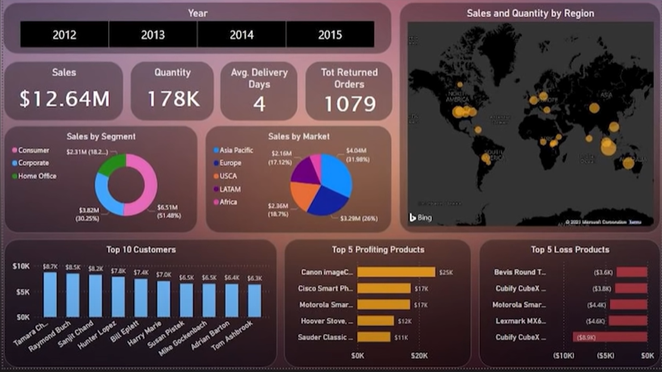

1. **Connecting Database:**

The data set can be found through Power BI sample Dataset or the given link below.

